State Bank of Patiala
General Secretary
B.C.Bassi
Patiala
9530519122
President
Harish Walia
Chandigarh
9815700573
Retired Officers' Association (Regd.)
31, NEW GREEN PARK COLONY, PATIALA
(Affiliated to All India Bank Retirees’ Federation )
Phone/Fax : 0175-2355031 Email:sbpretdpta@gmail.com
Website:sbpretdpta.com

Circular No. 2A of 2017-20 Dated 11th January 2018

Dear Members,

Implementation of Para 12 of 1993 settlement on Pension Scheme.

We give below text of letter No. 2018/006 dated 9th January 2018 sent to
The Chairman, Indian Banks’ Association, Mumbai sent by Shri S.C.JAIN, General Secretary AIBRF for information, the contents of which are self explicit.

Yours sincerely,

(B.C.Bassi)
GENERAL SECRETARY

Text

Re: Implementation of Para 12 of 1993 settlement on Pension Scheme.

We wish to invite your kind attention on Para 12 of Memorandum of Settlement dated 29.10.1993 introducing pension scheme in the banking industry which reads as under:

“ Provisions will be made by a scheme, to be negotiated and settled between the parties of this settlement by 31st December, 1993 for applicability, qualifying service, amounts of pension, payment of pension, commutation of pension, family pension, updating and other general conditions etc. on the lines as are in force in Reserve Bank of India.”

2.As per the above, it is obligatory on the part of the parties to the settlement to make suitable provisions on various issues of the pension including on Updation aspect in the final scheme to be adopted and implemented. First part of Para 12 “ Provisions will be made by a scheme” and its last part “on the lines as are in force in Reserve Bank of India” are of mandatory nature with no discretion to the parties to the settlement to drop any one aspect covered in Para 12 of the settlement. As per the above, it is necessary to make suitable provisions for Updation on the lines of RBI and modalities of the scheme can be negotiated and finalised.

3. But we find that suitable provisions for Updation of pension have still not been finalised through negotiation as provided in Para 12 0f 1993 settlement even after lapse of considerable period of 22 years.

4. In this regard we also wish to invite your kind attention on Judgement of Punjab & Haryana High Court dated 16.04.2012 on Civil Writ Petitions filed by some retirees on the issue of Updation of pension. While delivering the judgement, Honourable High Court judge has mad the following observations in Para 10 & 11 which are reproduced below:

10. “It is set out through the written statement itself that the
decision was communicated in the year 2005, but the writ petitions came to be filed more than 3 years in CWP No.6233 of 2008 and more than 5 years later in the batch of writ petitions in CWP No.12211 of 2010. No explanation has been given in the petitions as to why the petitioners had not immediately approached this Court. I am merely stating this in the passing that the petitioners could not have come to the High Court for enforcement under Article 226 when they could have only pressed for better rights through negotiations in the manner that the settlement talks provided. It would be open for the petitioners to make the demands for parity if they are so advised and use their bargaining skills through their associations and press for the reliefs though the mechanism provided under the Industrial Disputes Act. There existed no vested right now for the petitioners to claim the benefits in the manner sought.

11. All the writ petitions are consequently dismissed, however, subject to the above observations.”

6.In this regard, we also draw your attention on your circular No. HR&IR/KU/2015-16/G2/506 dated 17.10.2015 addressed to member banks on the subject.

5.The Honorable court has observed that petitioners can press for better rights on the issue through negotiation as provided in the settlement and the mechanism provided under Industrial Dispute Act. In Para 11 of the judgment, it is stated that disposal of writ petitions are subject of the above observations.

6. All India Bank Retirees’ Federation ( AIBRF) represents more than 1.70 lakhs retirees who are members of the pension scheme as formulated as per provisions of 1993 settlement. As you are aware, AIBRF is body registered under Trade Union Act. AIBRF and its 1.70 lakh members feel aggrieved and concern for inordinate delay in formulating provisions of Updation as provided in Para 12 of the settlement of 1993 signed and filed under provisions of Industrial Dispute Act and is legally enforceable.

2. We therefore demand that discussion should be held with AIBRF for negotiation and finalizing provisions of Updation scheme as provided in Para 12 of 1993 and as per the observations/ directions of Honorable Punjab & Haryana High Court.

With Regards

.
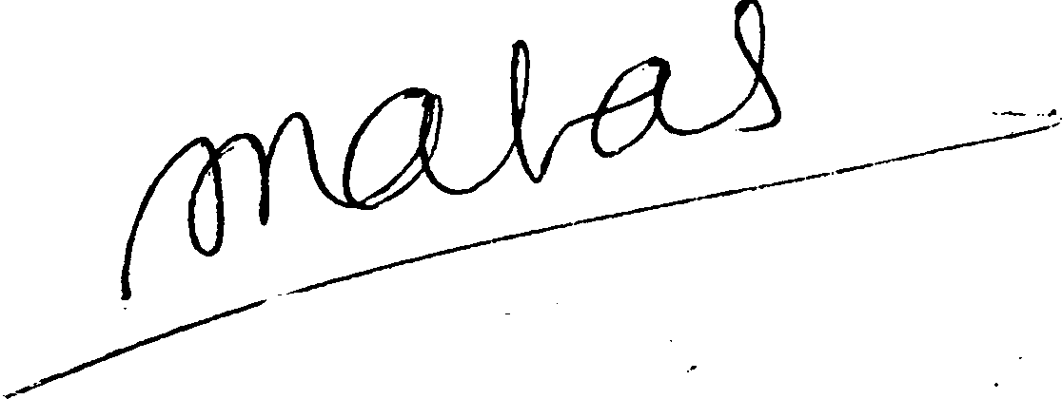
Yours Sincerely,

( S.C.JAIN)
GENERAL SECRETARY
C.C.to Deputy Labour Commissioner (Central)
Mumbai.

